- How are DoS attacks performed?
Flooding denial of service (DoS) attacks in the form of TCP SYN packets.
- Name and describe the tools that hackers use to cause a DoS.
LOIC (Low Orbit Ion Cannon): Generates large numbers of network requests against a target to consume its resources.
HOIC (High Orbit Ion Cannon): A more powerful traffic-generation tool designed to overwhelm web servers with HTTP requests.
- What techniques used to prevent Dos attack from happening?
Network Level Filtering
Rate Limiting
Load Balancing
Content Delivery Networks
- Give 3 examples of IDS systems.
Snort, OSSEC & Cisco Secure IPS
- Give 3 examples of an IPS systems.
Check Point IPS
Pal Alto Network
Hillstone Network Intrusion Prevention System (NTPS)
- Which IDS security control is a result of non-malicious action generally demonstrating an error?
False Positve
- Which abilities does an IPS have that an IDS does not?
Active Blocking, Inline Monitoring, Behavioural Analysis and Automated Response

- What is the difference between IPS and IDS?
Detection vs. Prevention: IDS monitors network traffic for suspicious activity and alerts security teams, while IPS actively blocks or mitigates threats in real-time.
Response Time: IDS operates passively, generating alerts after detecting threats, whereas IPS takes immediate action to prevent attacks.
- What are the kinds of attacks apart from Dos, does IPS protect the network?
Man-In-the-Middle Attacks, Spoofing attacks, credential stuffing and password attacks
- What is the difference between HIDS and NIDS?
IDS analyzes network traffic to find any vulnerabilities moving across the network, HIDS keeps an eye on every single devices, analyzing local performance for unusual patterns and assaults.
- How do you use a honey pot when utilising network protection with an IPS?
Define the Goal: Determine the specific purpose of the honeypot, whether it's for research, operational defense, or training.
Select the Right Type: Choose between low-interaction or high-interaction honeypots based on the complexity of threats and resources available.
Isolate the Honeypot: Ensure the honeypot is isolated from production systems to prevent real attacks from bypassing it.
Configure Realistic Content: Set up the honeypot to mimic legitimate services or applications, making it attractive to attackers.
Enable Logging and Alerts: Configure the honeypot to log interactions and alert security teams to potential threats.
Regularly Refresh the Environment: Keep the honeypot environment updated to reflect the latest attack tactics and improve its effectiveness.
- Find 3 hardware IPS Systems and costs.
IPS | Approx. hardware cost | Typical IPS/security licensing | Best suited for
Fortinet FortiGate 90G | ~£1,300–£3,700 | ~£4,200 for 1-year UTP bundle | Small/medium business
Cisco Secure Firewall 1210 | ~£1,900–£3,200 | Additional threat/security subscription | Medium business
Sophos XGS 2100 | ~£770–£1,000 | Additional Sophos protection licence | SMB / branch networks

- What Operating systems use iptables and what do they do?
iptables is a user-space utility program used primarily in Linux systems
- Give an example of an iptables.
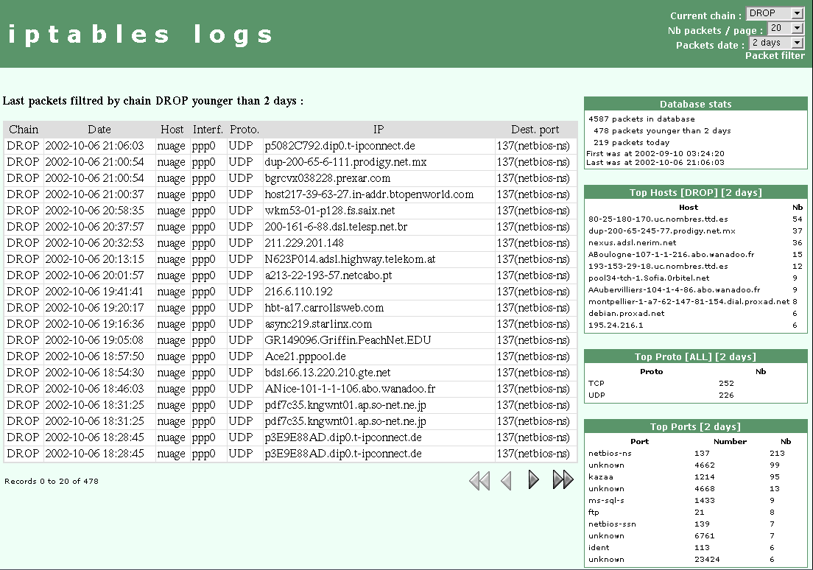
- What is an ARP storm and how does it work?
An ARP storm occurs when a network is flooded with excessive ARP broadcast packets, overwhelming network devices and degrading performance.
- Explain what Wireless Intrusion Prevention Systems (WIPS) do.
A Wireless Intrusion Prevention System (WIPS) is a network device designed to monitor and protect wireless networks from unauthorized access and potential security threats. It works by:
- Monitoring the radio spectrum for unauthorized access points (rogue APs) and suspicious activities.
- Detecting and blocking threats such as rogue access points, Wi-Fi spoofing, and man-in-the-middle (MITM) attacks.
- Automating responses to detected threats, such as blocking connections to rogue devices or notifying administrators.
- Consistently scanning for anomalies and alerting security personnel when suspicious activity is detected.
- WIPS is essential for maintaining the security of wireless networks, especially in environments where unauthorized access is a significant concern.

